SEX HORMONE DISORDERS
SUPPLEMENT TO DR. J. BAIN’S LECTURE

A/ Sexual Development after Conception

Principle – ALL human beings are destined to become female unless there is some form of active intervention causing them to become male.

Figure 1 – Fetal Anatomy prior to 8 weeks of Gestation
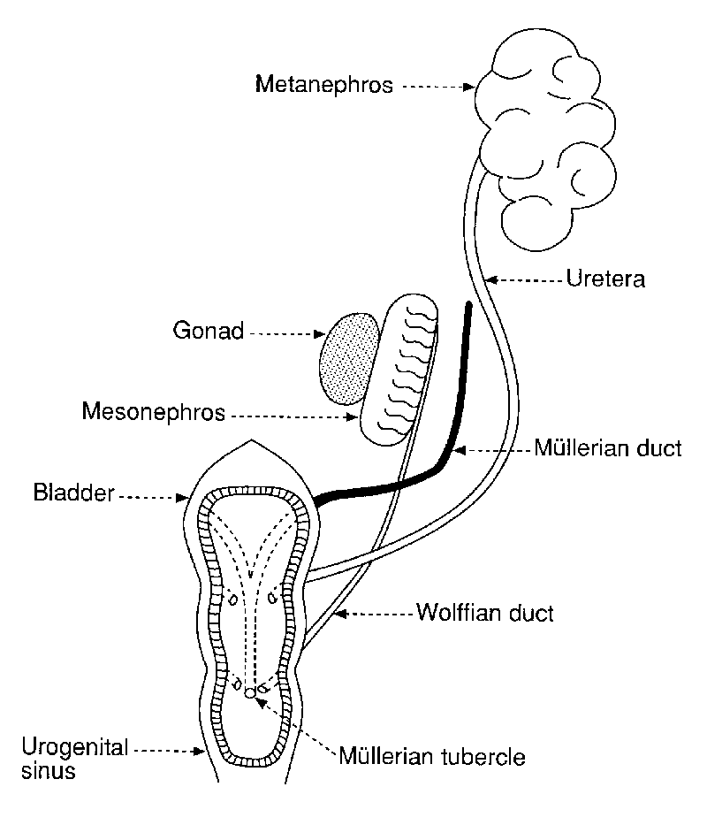
The development of human genitalia derives from the differentiation of two pairs of duct systems: the Wolffian ducts and the Mullarian ducts. In the female fetus, the Wolffian ducts degenerate; in the male fetus, the Mullarian ducts degenerate. Males secrete testosterone and Mullarian Inhibitory Factor (MIF), which stimulates the development of the testes, vas deferens, etc, as well as the closure of the urogenital sinus. In contrast, females do not produce testosterone (or at least negligible levels) or MIF. As a result, the Wolffian system breaks down, the ovaries are formed, and the urogenital sinus does not close, producing the vagina. (NOTE: MIF may also be referred to as Antimullarian Hormone (AMH))

FETUS
Male (XY)
Female (XX)

Testosterone

MIF
No Testosterone

No MIF

Wolffian (Testes)

Mullarian
(Ovaries)
Genetic Control – The dominance of one duct system over another is under significant genetic control. It is common knowledge that all typical females possess two X chromosomes and all typical males possess one X chromosome and one Y chromosome. Several years ago, a Y specific gene was detected and named the Testicular Determining Gene (TDG). The presence of this gene determines if the fetus will secrete high levels of testosterone and MIF.

Clinical Conditions – It would make medicine and pharmacy significantly easier if physiological processes occurred without error. As you know this is far from the case. During sexual development, many things can go wrong. Examples include:

- Male Pseudohermaphroditism – The patient’s karyotype is 46XY but the internal and external genitalia are ambiguous (patient is incompletely masculinized). External gonads often appear as testes. The pathological causes may range from androgen insensitivity (due to nonresponsive receptors or too few receptors) to persistent Mullarian ducts due to low levels of secreted testosterone.
- Female Pseudohermaphroditism – The patients karyotype is 46XX and the internal genitalia are feminized. However, the external genitalia are masculinized. This condition may be caused by maternal androgen excess (due to adrenal hyperplasia or ingestion of synthetic estrogens), enzyme deficiencies, or deficiency in placental or germ-line aromatase.
- True Hermaphroditism – Patients with this condition often have a 46XX karyotype; however, DNA from a Y chromosome has been translocated to one of the X chromosomes (this DNA may include sequences from the TDG). The end result is the development of male and female sexual characteristics. The clinical signs are an ambiguity in internal and external genitalia with trace microscopic evidence of both ovaries and testes.
- Klinefelter Syndrome – Klinefelter Syndrome occurs in 1 in 500 to 1000 live male births, which renders it the most common abnormality in sexual differentiation. The most common karyotype for these patients is 46XXY. As the Klinefelter patient develops, a number of abnormalities are apparent including smallish testes, infertility, bilateral gynecomastia (breast enlargement), and an abundance of pubic hair. Body proportions are also altered so that these patients are tall and slim with extremely long legs. Other conditions that may occur secondary to Klinefelter Syndrome include thyroid dysfunction, diabetes mellitus, and breast cancer. The pathophysiology of Klinefelter Syndrome is testicular dysgenesis (due to the extra X chromosome) that leads to a low level of serum testosterone. This is evident in the post-pubescent patient where the estradiol-to-testosterone serum level is extremely high.
- Turner Syndrome – Patients suffering from Turner Syndrome do not develop female secondary sex characteristics and do not have a menstrual period. The pathophysiology of this condition is ovarian dysgenesis leading to a dramatic reduction in serum estrogen. These patients often have high serum levels of gonadotropins, which indicate that the body is responding to the lack of estrogen. Patients with Turner Syndrome have infantile breasts, streak ovaries, and are often short in stature. The karyotype for these individuals is XO where O represents the absence of a Y chromosome. Since this Y chromosome is absent, these patients develop as if they were female.

Treatment – Pharmacological management of patients with abnormalities in sexual development is extremely limited. Patients with hermaphroditism may require surgery so that their external genitalia are characteristic of one gender or the other. Since gender is a psychological phenomenon (whereas sex is physiological), surgical reconstruction depends upon various factors including the patient’s upbringing (i.e.: as a boy or as a girl) and their perception of self. It is essential to appreciate that psychiatric counseling is perhaps the most important aspect of treating a patient with any form of gonadal ambiguity. Klinefelter syndrome is treated with testosterone replacement and Turner Syndrome is treated with estrogen replacement.

B/ Problems during Puberty

Principle – Most problems that occur with pubertal sexual development result from a failure to secrete sufficient amounts of sex hormones. Keep in mind that testosterone masculinizes and estrogen feminizes. Patients with abnormal pubertal development often present with an absence of secondary sex characteristics (i.e.: pubic hair, fat distribution, breast development, vocal changes). These problems result from either primary hypogonadism (problem with the gonads themselves) or secondary hypogonadism (hypothalamic or pituitary origin).

Figure 2 – Physiology of Sex Hormone Secretion

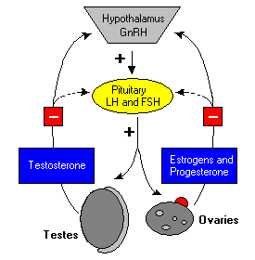

GnRH = Gonadotropin Releasing Hormone
FSH = Follicle Stimulating Hormone
LH = Leuteinizing Hormone

Clinical Conditions:

- Male Hypogonadism – This condition occurs due to inefficient or absent testicular function. Primary male hypogonadism may result from testicular inflammation (i.e.: mumps orchitis), cryptorchidism (undescended testes), trauma (such as castration), chemotherapy, and Klinefelter Syndrome. All of these conditions lead to a failure of the male to fully develop secondary sex characteristics. Secondary causes of hypogonadism include hyperprolactinemia (which suppresses production of FSH and LH), pituitary tumor, and GnRH insufficiency. Damage to certain regions of the hypothalamus causes a decrease in GnRH and, in turn, a decrease in secretion of FSH and LH from the anterior pituitary. If this occurs prior to the onset of puberty, a condition known as Adiposogenital (Frohlich’s) Syndrome occurs. This disorder is characterized by typical eunuchism (childlike development) coupled with severe obesity (caused by a central drive to overeat).
- Female Hypogonadism – In a manner similar to male hypogonadism, this disorder results from inefficient or absent ovarian function. Primary female hypogonadism may result from oophoritis, streak ovaries (i.e.: Turner Syndrome), premature menopause (due to autoimmune destruction of the ovaries), ovarian agenesis, and gonadal dysgenesis. All of these conditions lead to a failure of the female to produce estrogen and develop secondary sex characteristics. Secondary causes of female hypergonadism are exactly the same as for the male.
- Kallmann Syndrome – A form of secondary hypogonadism caused by a deficiency in GnRH. As a result, normal levels of LH and FSH are not secreted by the pituitary gland. It is a genetic condition where the majority of cases of inherited as an X-linked recessive trait, in which there is a defect in the KAL1 gene. KAL1 encodes a gene product known as anosmin-1, a neural cell adhesion molecule, which promotes migration of GnRH neurons into the hypothalamus during development. In approximately 10% of cases, the defect in inherited in an autosomal dominant manner, in which the defect occurs in the KAL2 (also known as fibroblast growth factor receptor-1).
- Infertility – Infertility affects approximately 15% of couples with male factors and female factors having equal causation. In order to understand male infertility, consider the cell types of the testicle: Sertoli cells are responsible for spermatogenesis and Leydig cells secrete testosterone. The testosterone from the Leydig cells stimulates the Sertoli cells to produce sperm. If the Leydig cells do not function correctly (i.e.: do not secrete testosterone), spermatogenesis cannot occur and the end result is infertility. Male infertility develops due to hypogonadism, substance abuse (cigarettes, alcohol, drugs), bilateral occlusion of the vas deferens, sexual dysfunction, or may be entirely idiosyncratic. Female infertility occurs due to a variety of factors including hypogonadism, androgen disorders, inefficient ovulation (e.g.: polycystical ovarian syndrome), endometriosis, and obstructed or diseased fallopian tubes.

Treatment – Hypogonadism is often treated by hormone replacement. In the case of male primary hypogonadism, testosterone administration is the front-line therapy. In male secondary hypogonadism, gonadotropins or testosterone may be prescribed; however, testosterone is used much more frequently. Various formulations of testosterone are available: testosterone cypionate, testosterone enanthate, and testosterone propionate are given i.m., methyltestosterone is administered orally or sublingually, and fluoxymesterone is prescribed for oral use. Keep in mind that testosterone is enzymatically converted (by 5α-reductase) to 5α-dihydrotestosterone in the adolescent and adult male. Both forms of testosterone may bind to the androgen receptor and initiate male sexual development; however, the 5α-dihydrotestosterone form is most prevalent. In female hypogonadism, the front-line therapy is estrogen replacement. During puberty, treatment is initiated with small doses of estrogens (0.3mg conjugated estrogen or 5-10μg of ethinyl estradiol) on days 1-21 of each menstrual cycle. When puberty is completed, chronic therapy consists primarily of estrogens and progestins.

With respect to infertility, therapy involves the treatment of the primary cause. In female infertility, a variety of treatment options exist. One such treatment is the ovulation-inducing agents such as clomiphene. Clomiphene is a partial estrogen agonist that induces ovulation after a single course of therapy. The mechanism by which clomiphene induces ovulation in unknown. Some adverse effects do result from this compound including hot flashes (most common), headache, constipation, allergic skin reactions, and reversible hair loss. Other treatments for female infertility include gonadotropins and GnRH. Interestingly, GnRH deficiency (as in Kallmann syndrome) can be treated using recombinant hCG since the body responds to hCG in the same manner as it does for the LH surge. In contrast, there are few treatment options for male infertility. Couples who are affected by male infertility often turn to in vitro fertilization or donor sperm insemination.

ASIDE – Metabolic errors in the male can prevent the development of secondary sex characteristics. They result from a defective or inefficient 5α-reductase, the enzyme that converts testosterone to 5α-dihydrotestosterone. If free testosterone remains in the circulation for too long, it is converted to estrogen. The end result is a feminization of the male (i.e.: gynecomastia, failure of the voice to deepen, lack of body hair).

ASIDE: Steroid Usage by Athletes

The use of anabolic steroids for athletic purposes has long been documented. Many of us remember Ben Johnson’s embarrassment in Seoul or Mark McGwire’s admitted use of androstenedione. These agents are used in order to enhance body protein production and increase muscle mass (one of the major activities of androgens in the body). However, they also have negative effects on the male reproductive system. Exogenous testosterone use downregulates the production of GnRH by the hypothalamus and FSH and LH production by the anterior pituitary. In turn, this causes the testicular Leydig cells to stop testosterone production (i.e.: an endogenous source of testosterone is no longer required). As a result, these cells atrophy, the testes shrink, and spermatogenesis ceases. This leads to a marked reduction in sperm count (i.e.: infertility) as well as pea-like testes.

C/ Sex Hormones and Aging

Menopause – When women reach their mid-40s to mid-50s, the sexual cycles become increasingly irregular, and ovulation fails to occur. Eventually, the cycles will cease entirely and this event is commonly known as menopause. The most pronounced physiological change during menopause is a rapid decrease in the production of the female sex hormones.

The cause of menopause is a ‘burning out’ of the ovaries. Throughout the female’s life, approximately 450 ovarian follicles will mature and release an ovum while the remaining thousands of follicles will degenerate. As women reach their mid-40s, only a few follicles remain to be stimulated by FSH and LH. However, estrogen production by the ovary decreases as the number of remaining follicles approaches zero. When estrogen production falls below a critical value, it can no longer inhibit the production of FSH and LH; nor can it stimulate the ovulatory surge of FSH and LH. As a result, the menstrual cycle becomes increasingly irregular until it ceases all together.

Many clinicians believe that postmenopausal women require some form of therapeutic intervention. This belief is based upon the distribution of estrogen receptors in the body. Estrogen receptors can be found in the ovary, uterus, breast, and bone. Estrogens enhance the coagulability of blood by increasing the circulating levels of factors II, VII, IX, and X and decreasing levels of antithrombin III. Estrogens also affect plasma lipid distribution by increasing high-density lipoproteins (good cholesterol), decreasing low-density lipoproteins (bad cholesterol), and an overall reduction in plasma cholesterol. As estrogen production falls off, a variety of pathological conditions may result. Perhaps the most prevalent is the onset of osteopenia or osteoporosis. Estrogens antagonize the effects of parathyroid hormone in bone by reducing the rate of bone resorption (they do NOT stimulate bone formation). As a result, bone resorption increases (and bone mass decreases) during the onset of menopause. In addition, menopause may lead to increased cardiovascular disease because of an alteration in the distribution patterns of plasma lipids.

Therapeutic Measures:

- Hormone Replacement Therapy (HRT) – Optimal management of the postmenopausal patient requires careful assessment of her symptoms as well as her relative risk for cardiovascular disease, osteoporosis, breast cancer, and endometrial cancer. It is well known that estrogen replacement in the postmenopausal women leads to an increased risk for both breast and endometrial (uterine) cancer. If the main symptom is hot flashes, low-dose estrogen for symptomatic relief is recommended. Treatment for a short time period is also recommended to avoid the increased risk of cancer. Many estrogen formulations also contain progestins, which act to mimic the premenopausal hormone cycle and have been shown to slightly decrease the cancer risk. Higher doses of estrogens may be required in patients who present with developing osteoporosis or cardiovascular disease. In general, the principle of HRT remains the same: prescribe the lowest dose of estrogen possible that will provide symptomatic relief. The recommended dosages of estrogen are 0.3-1.25mg/day of conjugated estrogen or 0.01-0.02mg/day of ethinyl estradiol.
- Tamoxifen – This drug is often used in postmenopausal women as a prophylactic agent against breast cancer. Tamoxifen (Nolvadex) functions as a partial agonist-inhibitor of estrogen and binds to estrogen receptors of estrogen-sensitive tissues. The recommended dose is 20 to 40mg daily taken in one dose or two divided doses. The most common side effects (greater than 10%) reported for tamoxifen are hot flashes and weight gain. It may also increase circulating cholesterol levels. Tamoxifen has been shown to interact with the function of warfarin.
- Raloxifene – The development of raloxifene (Evista) was a significant breakthrough in the management of menopause. Raloxifene is a selective estrogen receptor agonist; it acts as an agonist in the estrogen receptors in bone and in the circulation but has no effect on those in the uterus, ovary, or breast. As a result, this compound can effectively combat osteoporosis and cardiovascular disease but does not increase the relative risk of breast or uterine cancer. Patients with liver disease or thrombolytic disease cannot take raloxifene since the estrogen receptor agonist activity will magnify these conditions.
- Other Therapeutic Measures – Physicians often advise menopausal women to take calcium or vitamin D supplements to reduce the extent of bone loss. Other therapeutic measures include an exercise regimen that focuses on the weight bearing bones. Stress on the weight bearing bones (i.e.: femur, pelvis, spine) due to exercise stimulates bone formation and decreases bone resorption.

Andropause – Andropause is a hormonal and physiological change that occurs in men between the ages of 40 to 45 but it can occur as early as 35 and as late as 65. Some of the symptoms include decreased endurance during physical activity, bone deterioration, weight gain, loss or thinning of hair, sleep disturbances, and reduced libido. The main cause of andropause is a reduction in circulating testosterone levels. The effects of decreased hormone levels in men relate to the fact that men have five different testosterone cycles: rhythmic fluctuations, daily (high in morning and low in afternoon), monthly fluctuations, seasonal (higher in October and lower in April), and a general decrease during aging. This leads to an overall reduction in androgenic effects. Other hormones are also lowered, including dopamine, oxytocin, vasopressin, growth hormone, melatonin, pregnenolone, and thyroid hormone. Andropause has varying severity: some men may not even notice it has happened while others may require testosterone therapy.

Pointers for the Exam

- Focus on the hormonal and developmental cycles.
- Use these cycles to explain the pathophysiology of each condition.
- Understand why each therapy is appropriate for each condition.
- Understand why the side effects of each therapy occur.

